

Version 8.0.2

Introduction
The version 8.0.2 of WinPro introduces a new feature: the ability to manage several WinPro/D databases for your customers, onto a unique MySQL server dedicated to the program, allowing you to maintain only one technical database. This functionality is available only for versions further than the version dated from February 4th 2008. This feature is currently on testing on site with some of our customers, the final version will be released a few weeks later.

Overview
A WinPro/D database is installed on a MySQL server equipped with an internet connexion.
Onto the same server are created separated for each customer. Those databases will contain each customer proper files like Commande (Order Header), Detail (Order Detail), Client (Customer), Devise (Currency), etc…, along with views (VIEW) reaching technical tables from the fabricator.
Using MySQL, and an appropriate password strategy, allows then to have a unique server at our disposal for WinPro/D, where the customer is just able to browse the commercial data that's concerning him only. On a technical point of view, the set up is available for the customer, but only through his use of WinPro/D, as tables cannot be accessed straight.
Important note: considering the security level given to the accesses within this configuration as well as performance gains obtained, the encryption of fields previously used with FoxPro format has become unnecessary. Indeed, the physical content of the set up tables cannot be accessed directly by the user. Only WinPro/D can do this with calculating a complex password, together with the MySQL database.

Installation
- The following walkthrough may appear a bit long to read but they fully detail the process. Practically, the procedure is very simple to use.
- The first step is the installation of the MySQL server onto a machine with a high bandwidth Internet connexion. Be sure you are granted for creation of MySQL users from a remote machine, and take care with disabling the MySQL 'strict' mode at installation, as shown on below screenshots.
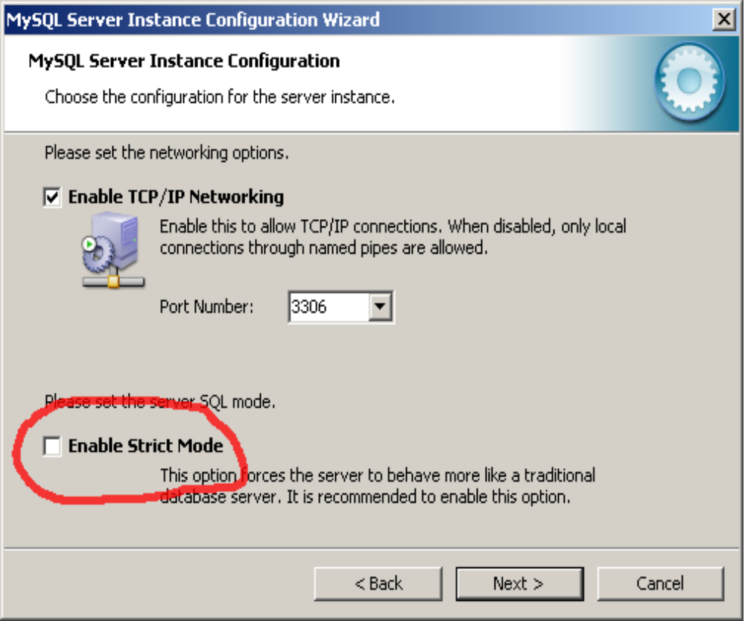
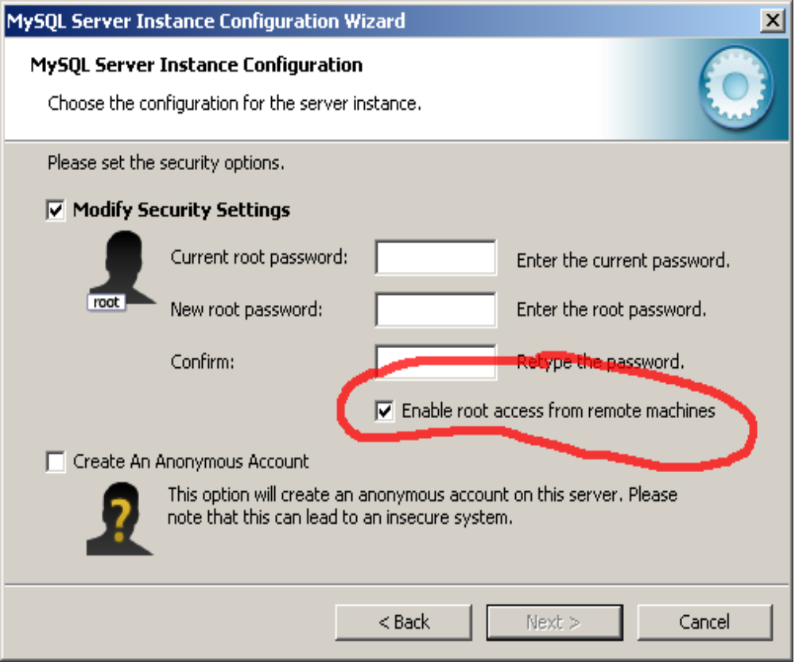
The remaining process goes through several stages, detailed further below :
  - Installation of the master WinPro/D executable
  - Creation of WinPro/D technical database extracted from WinPro
  - Creation of Customer Information for the master WinPro/D, extracted from WinPro
  - Installation of the Sentinel dongle.
  - Creation of the empty WinPro/D master database
  - Importation of the technical database extracted into the Master WinPro/D database
  - Initialization of WinPro/D
  - Creation of customers databases from WinPro production
  - Distribution of WinPro/D executable and connexion settings to your customers
- WinPro/D master must be installed on a workstation with access to the MySQL server assigned to WinPro/D. Your main WinPro installation must also be able to access this server. Both installations may reside on the same workstation.
- Export the ‘Settings’ table to a winpro.ini file (menu Tools | Export to Winpro.ini) (be cautious not to overwrite your main winpro.ini in your production directory !). If you skip this step, WinPro/D will create default values for all settings when creating its database.
- Update this WinPro.ini file, adding a [Database] section for the WinPro/D MySQL server access settings. See below details of the section :
[Database]
DLL=mysqldata.dll
Host=xxx
Name=yyy
Engine=zzz
Transactions=bbb
Character set=ccc
  - xxx is replaced with the hostname or IP address of the server (e.g. 192.168.1.1, www.Company_name.com, etc…)
  - yyy is replaced with the database label you want to assign to the database (WinPro will create it automatically). Examples: winpro, production,
  - zzz is replaced with the type of database engine you wish to use. For a basic installation, you can choose between ‘InnoDB’ and ‘myISAM’. We suggest using the InnoDb format for LAN or internet access. This engine supports transactions which appear to be safer. For a stand alone installation, the myISAM engine is enough as it is much more compact and lightly quicker.
  - bbb is to be replaced with 1 (default), or with 0. In case of value 1, WinPro will process a given number of processes (e.g. optimization) within a single transaction. Nevertheless, this may result in certain cases in slowing the overall system. This value may then be replaced with 0, but be aware that this option may cause operations to be a bit less safe. Note that in any cases, tables of myISAM format do not support such transactions; this option will then have no effect onto those tables.
  - ccc contains the character set to use; the default value is latin1, suitable for languages from occidental Europe area (French, English, Dutch, Spanish, Italian, German, etc...). This line is optional.
- To install the master WinPro/D database, copy the listed files onto a workstation:
  - WinProD.exe
  - Mysqldata.dll
  - Libmysql.dll
  - Clepar.dll
  - Cleusb.dll
  - Modules.dll
  - Stdreports.dll
  - Wpreport.dll
  - Optionally the specific.dll file (please advise us)
  - Any strings.* files
  - Your own lang.ini file
  - The mysql directory (contains the scripts needed for table creation; same directory as WinPro production).
- From WinPro production, extract a technical database for WinPro/D using the appropriate Tools sub-menu. A single file will now be created, named data.pak, and located into a sub-directory labelled Devis.
- Still from WinPro production, create an Infocli set of data from any customer in the list (menu Tools | Customer information for WinPro/D)
- Copy required files into a directory accessible for WinPro/D, including :
  - data.pak
  - infocli.dat
  - licence.ini
  - winpro.lic
  - and optionally, when required
    - site.var
    - remise.var
    - specif.var
- Install the Sentinel dongle driver if required, and plus the dongle in.
Note that you may feel free to install from a station where WinPro is installed, with the benefit of the Sentinel dongle already running...
- Be also sure that the winpro.ini contains any required settings, because they will be imported basically into the Settings table of the master WinPro/D. If necessary, extract table Settings of WinPro production toward a new winpro.ini file that you will copy into the appropriate WinPro/D directory, before modification. Without anything sets in the file, WinPro/D will generate default values for missing settings for a safe start of the program.
- Be sure that the section [Database] of winpro.ini file is correctly set for reaching the WinPro/D MySQL server
- In case another WinPro/D licence has been already installed on the machine, it is necessary to delete the following keys into the Windows registry database: section HKEY_CLASSES_ROOT, keys ‘WinProD’ and ‘HP’.
- Run the master WinPro/D. At login dialog, input your mySQL access codes (needed for database creation), and check the connexion settings, When WinPro/D asks for it, please confirm you want to « Create a new database ».
- Leave WinPro/D create an empty database, lasts for a few 10th of seconds!
- When the empty database is created, WinPro/D asks for the location of the licence.ini file
- After reading the licence.ini file, the 'Company' dialog appears. Input something into the first field ('Sous-titre', SubTitle).
- Execute the menu Utility | Import fabricator data. WinPro/D asks for location of the data.pak file extracted from WinPro production, and then import the data from the file into the master database.
- Open the Tools | User dialog, select user Administrateur, and set it a password. Attention !!! As your database is accessible from the Internet, it is strongly recommended to use a safe password strategy, including a mix a upper and lower case characters, digits, and special characters into a string with no significance!!! You may now create new users if required.
- Open the Data | Currency dialog and create at least your basic currency, with a change rate of 1 and the appropriate number of decimals. You may also create the other needed currencies for your customers, if required. Your customers will use a copy of this one when you will create their databases, and they will be able to customize it as for their needs.
- Open the Tools | Preferences dialog… and check the overall settings as for your needs. Your customers will use a copy of those preferences when their databases will be created, they will also be able to customize it.
- Open the Tools | Main system dialog, and select your own default system. Your customers will receive a copy of this information, which they will be able to customize for their needs.
- Open the Tools | VAT rate dialog, and indicate the various VAT rates to be used. Your customers will receive a copy of this information, which they will be able to customize for their needs.
- At this stage, you must exit from WinPro/D. You can now create the databases for your customers.

See page 6
Start WinPro production, and select the menu Tools | WinPro/D through Internet. The below dialog appears:
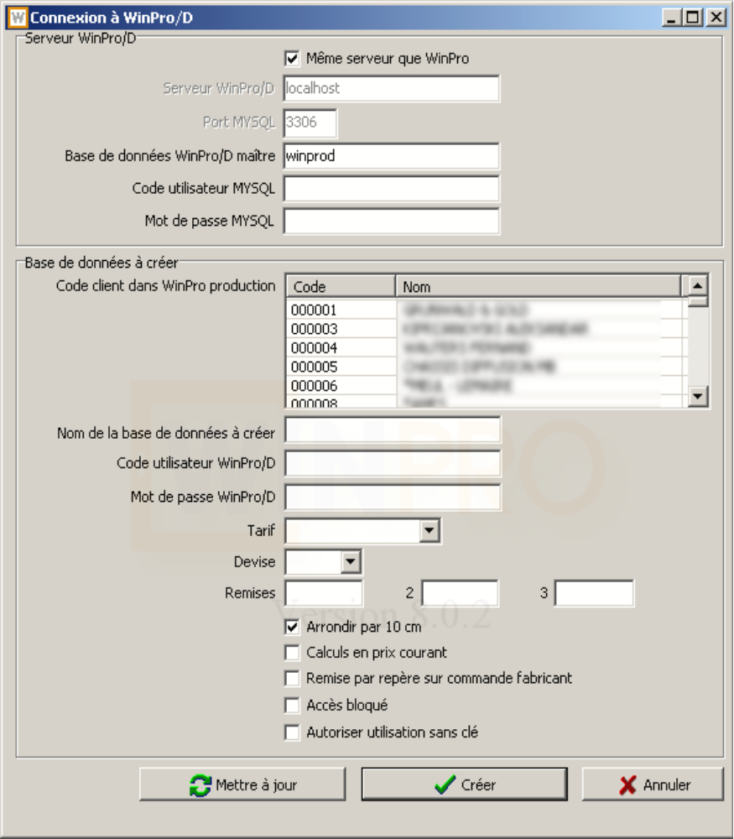
- Input frame WinPro/D Server
  - Same server as WinPro : check this box when the WinPro & WinPro/D databases are located onto the same machine. Note that we strongly recommend avoiding such a deployment which weakens your security.
  - WinPro/D server : Input here the server address on which the master WinPro/D database is located
  - MySQL port: Port number for MySQL access on this server
  - WinPro/D master database: Name set for the WinPro/D database when created.
  - Those 4 above settings are stored into the database, into table Settings of WinPro production, section WinPro/D. They will be required each time this dialog is enabled.
  - MySQL user code: Input the user code for MySQL access (and not the code for accessing the WinPro/D database!).
  - MySQL : Access password for MySQL related to the user code previously set.
  - Both settings will not be recorded into the database, for security reasons.
- Input frame Slave WinPro/D database:
  - Customer code in WinPro main database: this list shows the customer file as filled into the WinPro production database. Select here the customer who will use the generated database.
  - Name of slave winPro/D database: Input here the database name assigned to the customer. It is recommended to use the customer code, for an easy maintenance.
  - WinPro/D user code: Assign here a WinPro/D user code to your customer. A new user will be created into his WinPro/D database, with every access rights. Your customer is then free to add any users required.
  - WinPro/D password: Set here a password for your customer. Here again we insists on the pertinence of a safe password strategy, for yourself and for your customers.
  - Price list: Price list code assigned to the customer
  - Currency: Your customer's currency. It is better to have set it first into the master Winpro/D currency table.
  - Discounts: Discount awarded to your customer. Note that the discount formulas will also be transferred, without any intervention from you.
  - Round up to 10cm : Set here if the prices calculated by your customer will be rounded up to 10 cm for a given design dimension
  - On current prices: Set here if calculated prices will be based on Current or List prices.
  - Discount per windows on orders: Set if the detail of discount should be displayed for each design onto the paper order form sent to you by your customer.
  - Locked access (Accès bloqué): allows you to forbid the access to the database.
  - Allow use without dongle (Autoriser utilisation sans clé) : Leaves you allow the use of the program without a Sentinel dongle. In this case, the number of designs input into a given order or quotation will be transferred automatically to Quadrature, and an invoice will be established proportionally to the number of lines reported. On another hand, you may supply the program to your customers for free with this deployment. The below table shows the program behaviour according the status of this checkbox, and the use of the Sentinel dongle or not:

 | With Sentinel dongle | Without Sentinel dongle
Use without dongle allowed | Allowed configuration  No lines tracking for invoicing  Licence required | Allowed configuration  Invoicing for any line recorded  No licence required
Use without dongle forbidden | Allowed configuration  No lines tracking for invoicing  Licence required | Unauthorized configuration

The main advantage of a use without dongle configuration is to allow a temporary access to some of your customers, or for customers with a small volume of use, without the constraint of a dongle which is a costless solution.
- Create button
Click on this button to create the database for your customer. If the database already exists on the server, an error message is displayed. Refer then to the next paragraph, 'Update' (‘Mettre à jour’).
The creation process achieves the following steps:
- Check validity of input information, with an error message in case of missing setting.
- Storage of input information into WinPro production database
- Connexion to the WinPro/D server
- Creation of the customer database
- Creation of 'commercial' tables into this database, the tables containing the customizable settings for each customer.
- Creation of views onto the technical tables contained into the master WinPro/D database. This implies that you will have only a single database to maintain!
- Creation and duplication of the dict table as contained into the master WinPro/D database
- Creation of a user into the customer WinPro/D database, with the code and password you previously set
- Creation of user rights, necessary and sufficient, for this user into MySQL. Those rights are granted and applied onto the whole WinPro/D database for this customer; every rights are allocated, except SHOW DATABASES, SHUTDOWN and SUPER. the CREATE VIEW access right is also applied onto the master database; this is necessary for potential update of the views. A MySQL password is also generated, and you have no direct access to it, or your customer. This password is generated using the same rules as for password generation using WinPro production; refer to the corresponding chapter of WinPro 8 release notes for more details.
- Creation of a record into table Societe. This record will receive the name of your customer, as defined into your WinPro production customer file Client (and as shown into the list of customer within the « Customer information for WinPro/D » dialog)
- Copy of the content of table Devise (Currencies) from the master to the slave database.
- Copy of the content of table Settings from the master to the slave database.
- Storage of connexion and authentification settings into table Settings of the slave customer database, section WinPro/D :

Key (Key field) | Content
Client | Customer code within WinPro production
Code Tarif | List price code set for the customer
Coeff | Multiplying coefficient of the list price code set for the customer
Devise | Base currency for the customer
TauxDevise | Multiplying coefficient of the base currency for this customer
Remise1, Remise2, Remise3 | Base discount awarded to the customer
Arrondi | 1 if dimensions of designs have to be rounded up to 10 cm for price calculation, 0 otherwise
Prix Courant | 1 for price calculation based on current prices, 0 otherwise
Remise par repere | 1 for calculation of discounts by lines onto fabricator order form, 0 otherwise
Intercalaire | Multiplying coefficient for the price of the glazing in case the specific colour for spacer feature is used
Bloque | 1 if the customer is not allowed to access his database anymore, 0 otherwise
Internet | 1 if the customer is allowed to use the program without the Sentinel dongle, 0 otherwise
Licence | Copy of the winpro.lic licence file
Site | Copy of the site.var file
VarRemise | Copy of the remise.var file
VarSpecif | Copy of the specific.var file

- Update (Mettre à jour) button
Click this button to update an existing WinPro/D database. If the database is not already existing, an error message is displayed. Refer to the previous paragraph, ‘Create’.
The update process achieves the following steps:
- Check validity of input information, with an error message in case of missing setting.
- Storage of input information into WinPro production database
- Connexion to the WinPro/D server
- Refresh of the views into master database
- Modification or creation of the user set into the customer database
- Allocation of MySQL user right for this user
- Update of the Societe (Company) table content
- Storage of the customer settings, as described into the above table.
- Abort (Abandon) button:
Abort the procedure.

Broadcast of WinPro/D
The broadcast of WinPro/D for a MySQL connexion via Internet require less files than the Foxpro version as well as for the master WinPro/D version. Needed files are listed below:
  - WinProD.exe
  - Mysqldata.dll
  - Libmysql.dll
  - Clepar.dll
  - Cleusb.dll
  - Modules.dll
  - Stdreports.dll
  - Wpreport.dll
  - Optionally the file named specific.dll (please advise us)
  - Any strings.* files
  - Your own lang.ini file
  - The mysql directory (contains the scripts needed for table creation; same directory as WinPro production).
  - A WinPro.ini file, with adapting the [Database] section to the WinPro/D MySQL server access settings, and to the specific database settings for this customer
Moreover, you will have to communicate to your customer his access code and password.
Finally, you will have to distribute the Sentinel dongle with its driver, except if you wish to work without dongle (see the corresponding chapter at the end of the document).
Those files would require an upgrade only in case of significant changes or new feature within WinPro/D.
The only file specific for each customer is WinPro.ini, because it contains the connexion settings. All keys others than the ones included into the [Database] section must be deleted, as they are stored into the Settings table created in the database assigned to the customer.
No more broadcast for technical data or licence required, those data are included into the MySQL database that the customer can access, and will be exploited from this location.

First start for a customer version
At the first start stage, WinPro/D displays the company label dialog, which allows the customer to input his suitable text for his company. As long as nothing is input into the Sous titre (Sub-title) field of the dialog, it will appear again at every start of the program. In order to bypass the dialog, or if nothing needs to be indicated, the customer may input a single dot.
It is recommended for the user to check the validity of the settings into the Tools menu, and adapt it as needed,
The document layout may also need to be adapted (into menu Tools | Preferences…, tabs Customer documents, Invoice and Drawing), eventually according a customized logo.

Updates / upgrades
For the program itself, the upgrade of WinPro/D, for a MySQL connexion via Internet, is processed with distributing the same files than for an installation, except the winpro.ini file.
Concerning the update of technical data, only the master WinPro/D database needs to be updated, with importing the fabricator data again after extraction from WinPro production. This needs to be done once, on the master database, do never try to update the slave databases.
Finally, for the database structure which evolutes with the WinPro version number, the behaviour is described below:
- Master database upgraded before the slave database: the customer keep on using the program as usually without taking care of the modifications. However, the new feature won't be available until the customer has installed the same version of WinPro/D as the fabricator. When the customer receives the new version, WinPro/D upgrades the tables that are specific to the customer targeted, and refreshes the concerned views.
- Slave database upgraded before the master database: WinPro/D upgrades the customer database, but is intended to fail finding the fields it needs into the views toward the master database. This deployment is then to avoid absolutely.

Restrictions of use onto the slave database
A single restriction known this day: the customer cannot access the menu to import data from fabricator. This is obviously necessary and critical!

Volumes of data and connexion speeds
We tested without troubles the creation of 250 slave database, along with the master database, onto a small test server. An empty database is about less than 1Mb on the server. You will need to add the space for specific tables for each customer (tables for customers, orders & quotations, representatives, etc).
The number of 250 may be passed easily, but the Internet connexion speeds may be considered too.
The most important imitating factor is the number of simultaneous connexions. According our first evaluations, an average of 512Kb by user simultaneously connected is required for a correct use, and a minimum de 2Mb globally for good performances (then no more than 4 users simultaneously in this case). It is probable that above 10 simultaneous users connected, the necessary bandwidth decreases significantly in average by user, because statistically every user won't read or write data into tables at the same time, but feedbacks are missing for us to supply more information. We think that for 50 simultaneous users, the required bandwidth would be of about 20Mb at the server level, using a SDSL line.
At the user side, we recommend a minimum of 1Mb for download, and 512Kb for upload. It is obvious that a higher speed line would bring more speed, but if the server line is adapted.
At the server level, the processor load will be relatively limited, but an as large as possible RAM memory amount is better, as well as a good SCSI disk system.

Invoicing for use without dongle
Into this mode, the information collected onto our server is listed below:
- Fabricator number: a number for internal use by Quadrature, corresponding to your company. No other information are transferred
- Customer code: your WinPro code of the concerned customer. No other information concerning the customer are transferred
- Order number : the order number input by the customer
- Number of lines: number of order lines (designs) recorded. Additional articles, profiles, installation articles and bent sheets are not counted here.
- Date and time recorded for the first order line creation.
- The 3 last settings are the only settings transferred for each order recorded by your customer
- The above listed settings are the only settings transferred to us.
This feature is supplied as for experiment purpose. It will not be invoiced before a full validation. Nevertheless, you will receive the log files created onto our server, for information or validation purposes.
To conclude, the invoicing rate for this feature is still undefined.

